TODAY’S TAKEAWAYS
GRAMMAR | VOCABULARY | PRONUNCIATION
- ma’am
- man
- drunk: bêbado
- drink – drank
- take – took
- do the dishes: lavar a louça

Daniel comeu massa ontem.
Daniel ate pasta yesterday.
Ele não comeu arroz, feijão e carne.
He didn’t eat rice, beans and meat.
Ele comeu duas porções?
Did he eat two portions / servings?
Sim, ele comeu.
Yes, he did.
Ele bebeu água durante a refeição?
Did he drink water during the meal?
Não, ele não bebeu.
No, he didn’t.
O que ele comeu na sobremesa?
What did he eat for dessert?
Nada.
Nothing.

VERB TO BE IN THE PAST
Affirmative:
- I / he / she / it was
- you / we / they were

Negative:
- I / he / she / it wasn’t
- you / we / they weren’t

Interrogative:
- Was I / he / she / it?
- Were you / we / they?

John estava na festa ontem.
John was at the party yesterday.
John não estava em casa.
John wasn’t at home.
O John estava com a Mary?
Was John with Mary?
Sim, ele estava.
Yes, he was.
O John estava bêbado?
Was John drunk?
Não, ele não estava.
No, he wasn’t.
Por que ele estava nervoso?
Why was he nervous?
Ele não estava nervoso.
He wasn’t nervous.

My friends were at the gym yesterday.
My friends weren’t in the park yesterday.
Were your friends at home?
No, they weren’t.
Were your friends together?
Yes, they were.
How long were your friends at the gym?
For about 1.5 hours.

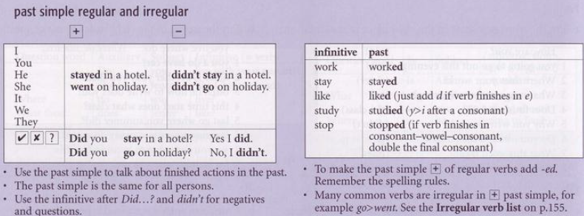

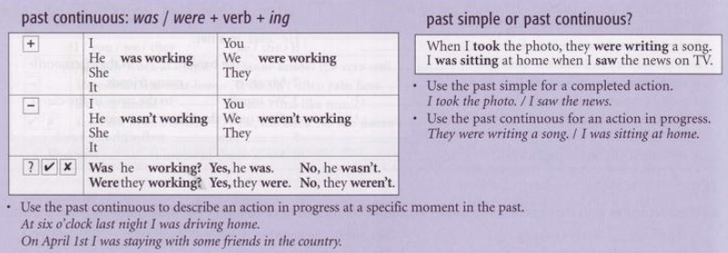
When I took the photo, they were writing a song.
They were writing a song when I took the photo.

While: enquanto
I took the photo while they were writing a song.
While they were writing a song, I took a photo.
When they were writing a song, I took a photo.

While I was doing my English class, my wife was doing the dishes.

